# Build image
docker build -t cats-dogs-api .
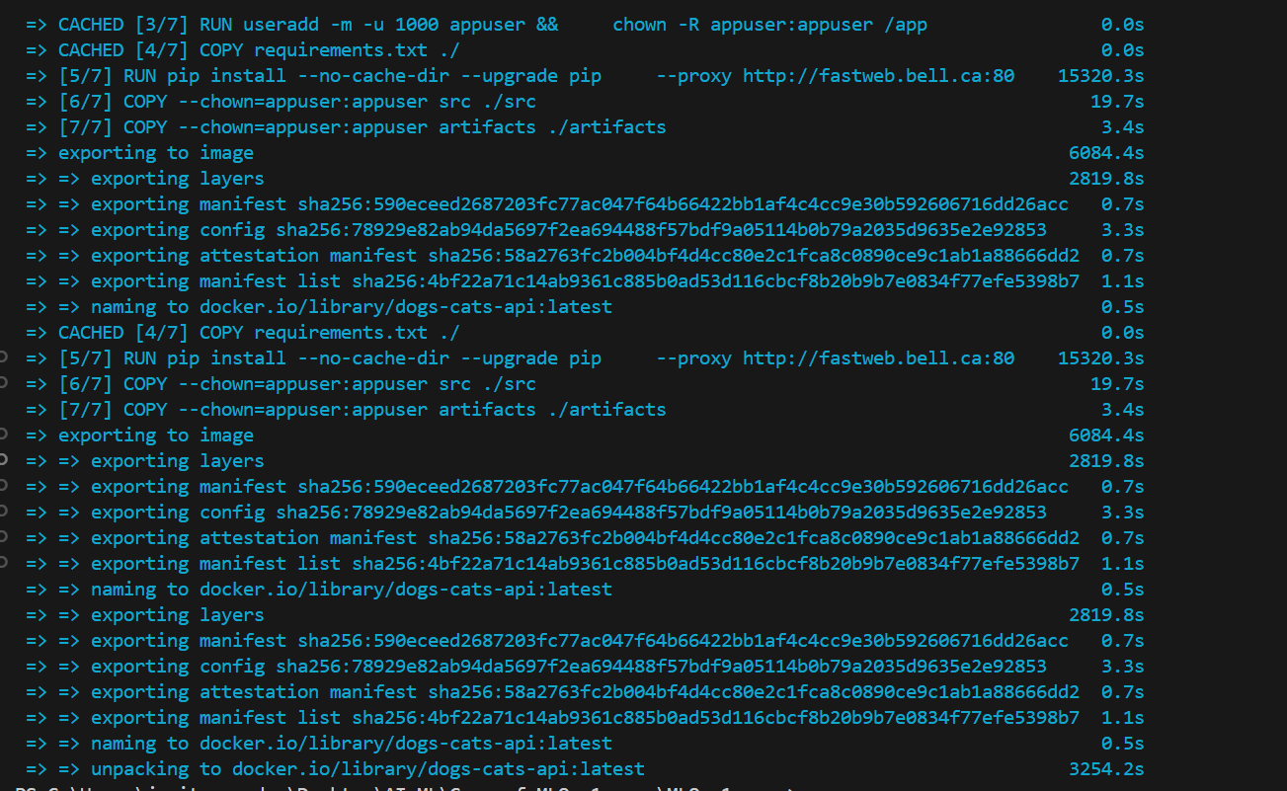

# Run container with health checks
docker run -p 8000:8000 dogs-cats-api
- Docker pings /health every 30 seconds to verify the container is still running and healthy.
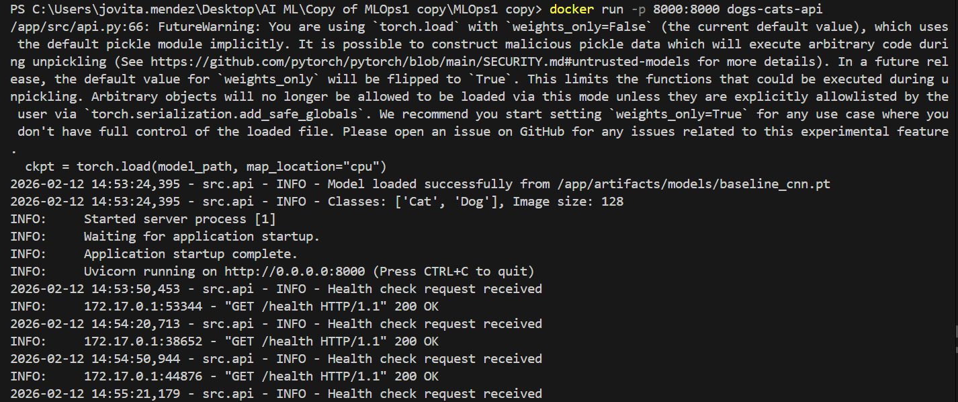
# Then test health
curl http://localhost:8000/health
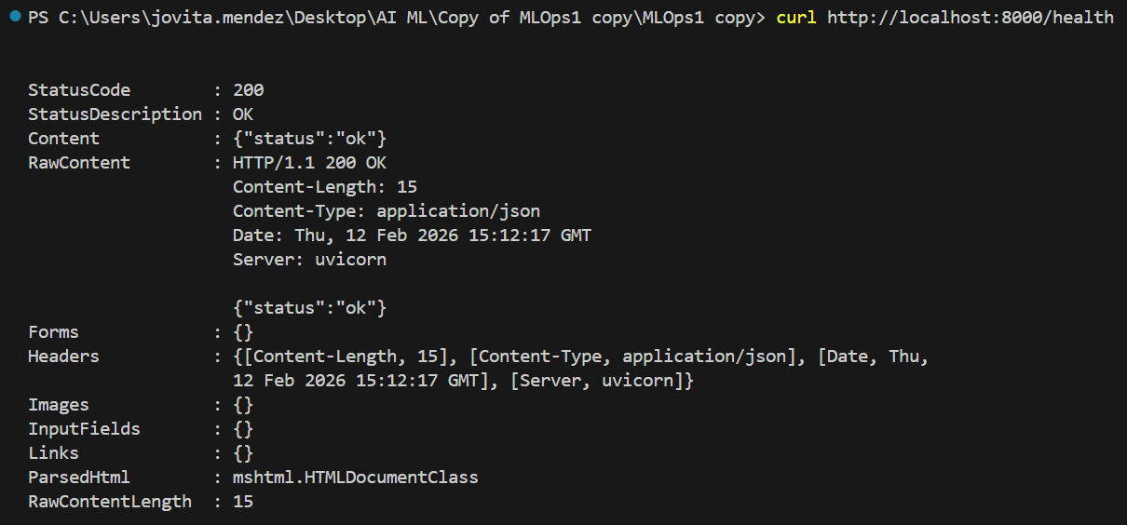

# Test prediction (replace path with actual image)
Test with Cat image:
curl.exe -X POST "http://localhost:8000/predict" -F file=@C:\Users\jovita.mendez\Desktop\AI ML\Copy of MLOps1 copy\MLOps1 copy\images\Cat.jpg

Test with Dog image:
curl.exe -X POST "http://localhost:8000/predict" -F file=@C:\Users\jovita.mendez\Desktop\AI ML\Copy of MLOps1 copy\MLOps1 copy\images\Dog.jpg

